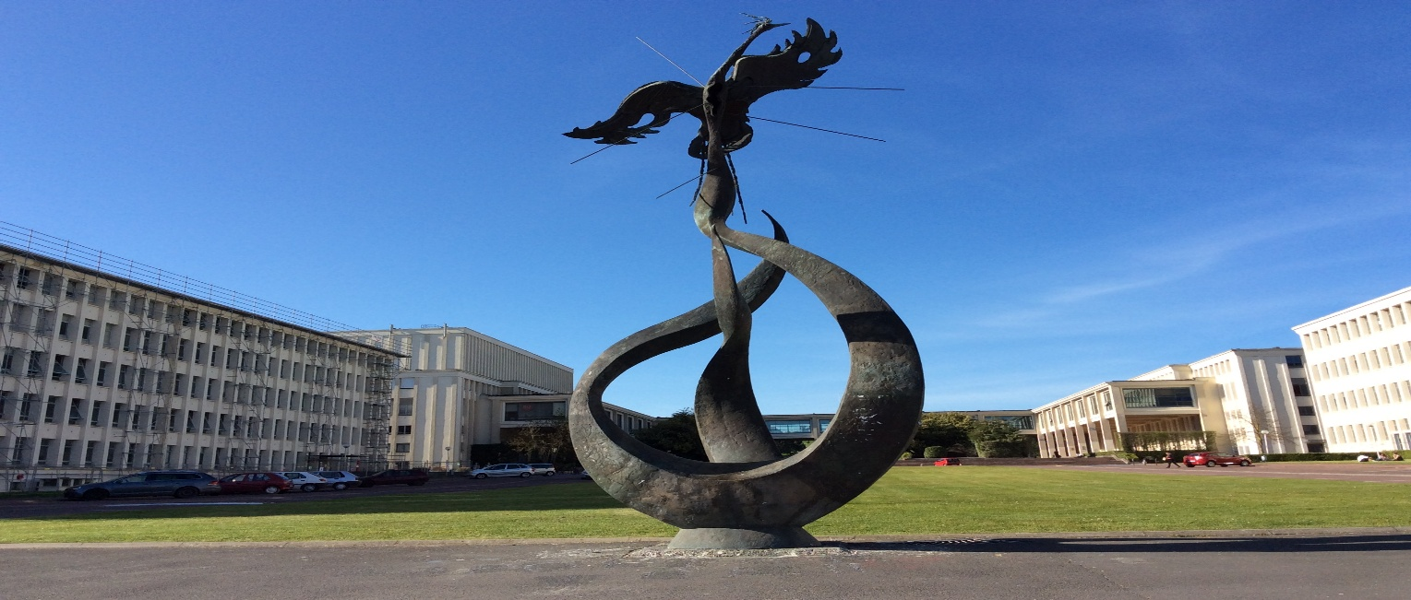
PhD Position in Molecular and Cellular Aspects of Biology
specialization in neuroscience
University of Caen Normandie

Development of a therapeutic vectorization strategy towards the central nervous system to limit neuroinflammatory and autophagic sequelae after traumatic brain injury and improve post-stroke outcome

Host laboratory: INSERM UMR-1237 – PhIND “Physiopathology and Imaging of Neurological Disorders”; Blood, Brain & Memory @ Caen Normandie Institute
Starting date: October 2026
Duration: 36 months
Funding: Fully funded PhD position (University of Caen)
Key-words: Drug delivery, Brain barriers, Stroke, Traumatic brain injury.

Project summary: Despite recent therapeutic advances, the effectiveness of treatments targeting the central nervous system (CNS) remains limited by the low penetration of molecules across CNS barriers. The hosting lab has recently developed a click-chemistry strategy allowing the passage of biologically active compounds across CNS barriers. The main objective of this thesis will be to develop and evaluate a vectorization strategy of a therapeutic and/or diagnostic molecule targeting neuroinflammatory and/or autophagic pathways, in order to reduce the histological and functional (short and mid-terms) consequences of stroke or traumatic brain injury (TBI).
The project will be based on a translational approaches including : 1/ click-chemistry of therapeutic/diagnostic candidates of various sizes and natures (including siRNAs, antibodies, radioligands…) ; 2/ in vitro and ex vivo models of CNS barriers (including iPS) and imaging modalities (confocal microscopy, NIRF, PET) to evaluate brain penetration of therapeutic/diagnostic candidates ; 3/ animal experimental models of stroke and TBI, coupled to macroscopic (MRI), functional (behavioural assays) and microscopic (ICH, O-Link, MSD) readouts. The PhD candidate will be involved in several parts of this project.
This project is therefore at the interface between neuroscience, nanomedicine and translational pharmacology, with strong potential for clinical innovation in the treatment of acute and chronic brain injuries.
Description of the host laboratory: The INSERM research unit “Physiopathology and Imaging of Neurological Disorders” (PhIND), directed by Prof. Denis Vivien, is internationally recognized for its expertise in stroke research, neurovascular biology, and imaging innovation. The unit is located at the Cyceron Center in Caen, Normandy (France), a leading multidisciplinary research environment providing state-of-the-art facilities in molecular and cellular biology, experimental surgery, and in vivo experimentation, together with a large animal facility affiliated with the University of Caen Normandy.
The PhD project will be carried out within the TRANSCEND team directed by Prof. Richard Macrez and Dr. Benoit Roussel, within the PhIND unit. The team develops translational approaches in cerebrovascular diseases, with particular expertise in stroke pathophysiology, cellular and molecular biology of the neurovascular unit and biomarkers. This PhD project will be conducted under the supervision of Prof. Ali.
PhIND is affiliated with the Blood, Brain and Memory @ Caen-Normandie (BBM@C) institute, which
provides access to several cutting-edge technological platforms, including sequencing facilities (InnovaSeq), biobanking and human sample analysis infrastructures (InnovaBIO), and advanced imaging facilities integrated within the France BioImaging network.
All the technological and material resources required for the project are already available and fully operational either within the laboratory or through local core facilities, ensuring the feasibility of the project.

Candidate profile: The candidate must hold a Master’s degree in biology, neuroscience, or a related field. The candidate should demonstrate a strong interest in neurovascular biology, preclinical and translational research, and projects bridging experimental neuroscience with clinical applications. Proficiency in either French or English is required. The candidate should hold accreditations for animal experimentation. Prior experience with techniques relevant to the project including either molecular/cell biology, animal models, imaging, behavioural assessments, and statistical analyses will be considered a strong asset. The candidate is not expected to master all experimental approaches at the initiation of the project.
Application before July 3, 2026: Applicants must submit a CV and a cover letter as part of their application. They are also encouraged to provide a letter of recommendation.
Contact: Professor Carine ALI (ali@cyceron.fr)

